Chapter 19, Problem 52.

- For the T network in Fig. 19.106, show that the h parameters are:

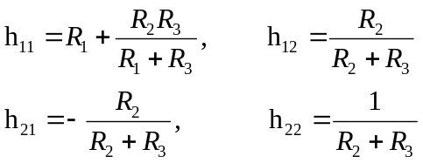

  - For the same network, show that the transmission parameters are:

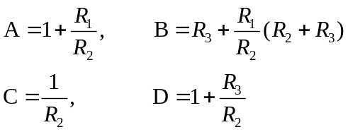

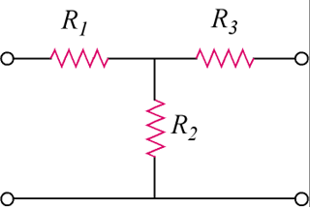

Figure 19.106
For Prob. 19.52.

